EE 374

FUNDAMENTALS OF POWER SYSTEMS AND ELECTRICAL EQUIPMENT

2021-2022 SPRING

TERM PROJECT

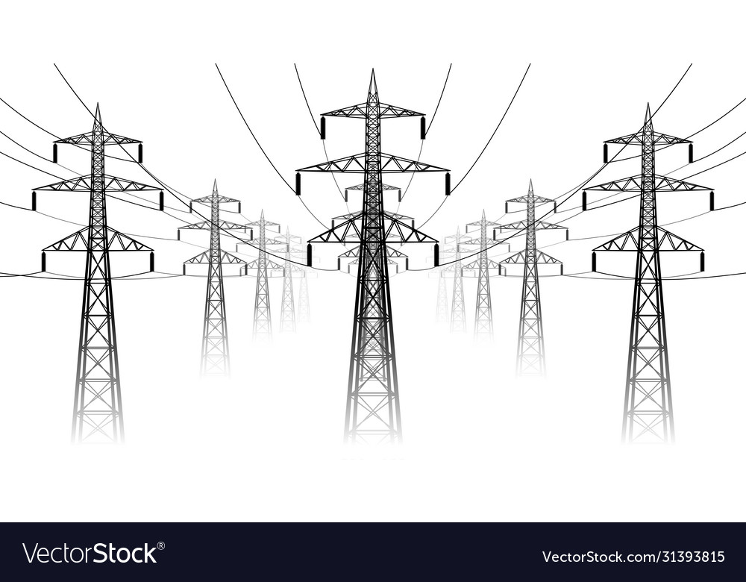

Afer OLKAY

2305126

# EMPLOYED METHOD AND ASSUMPTIONS

## Assumptions

During the calculations, I made the assumption that distance between conductors is much smaller than the distance between phases.

## Method

To observe the certain parameters’ effect on the circuit parameters, I did separately measurements for each parameter. When I examine a certain parameter, I give 2 to 6 different values for that parameter but make sure the other parameters are constant. Moreover, I used the example input text files that is provided in ODTÜClass and tested various values on the text and used the function that I created in phase 2. To do this I wrote an automation code where it quickly sweeps values for the parameter in test and plots the corresponding graphs. Function header can be seen below:

function txt_write_plot(target_file,parameter_in_test,values,default value)

an example input: target_file= "Input_file_example1.txt" ;

parameter_in_test="N_bundle" ;

values=[1 2 3 4 5 6] ;

default_value=4 ;

# TEST RESULTS & OBSERVATIONS

## Number of Circuits



Figure . Parameter change when number of circuits changes.(calculations made on input_example1)

It is seen that, when 2 circuit plan is used compared to single circuit plan, both resistance and reactance decreased significantly, almost the half of the value of that of single circuit. This can help decrease the losses. On the other hand, susceptance increases, which might cause some extra reactive power. It is worth noting that reactance has a much higher impact on transmission lines than susceptance, therefore overall, the effect of susceptance should shadow that of susceptance. This generalization is made throughout the other parameters also. Thus, higher number of circuits is beneficial for the designer.

## Conductors in a Bundle



Figure Parameter change when number of conductors in a bundle change.(calculations made on input_example1)



Figure . Parameter change when number of conductors in a bundle change.(calculations made on input_example2)

As the number of conductors in a bundle increase, generally resistance and reactance decreases and susceptance increases. Interestingly when 5 conductors used in a bundle it performs worse than 3 or 4 conductor models. Again, using more conductors can help us diminish losses and excessive current although extra line usage will cause extra expense which is undesired. Also, it is worth noting that as the number of conductors increase, decrease or increase of the variables that we interested in gets slower. Which means designer should look for the sweet spot that the extra cabling should equal to the diminished power loss cost.

## Bundle Distance



Figure . Parameter change when distance between bundles change.(calculations made on input_example1)



Figure . Parameter change when distance between bundles change.(calculations made on input_example2)

When bundle distance is increased, resistance does not change, whereas reactance and susceptance decrease and increase, respectively. This is great because, basically there is no extra charge for extra cabling, and we decrease our reactive power and current. Although as the distance increase, it may be a challenge to keep the bundle together as a whole. Another thing to watch out is that when we do our calculations, we assume that distance between different bundles is much larger than distance between conductors. Therefore, as the bundle distance increase, our calculations might not hold up to reality.

## Length of Line



Figure 6. Parameter change when length of the transmission line changes.

As expected, all parameters increase proportionally to the length of the line. So, length of the line should not be considered when designing a transmission line according to our area of experiment.

Even though they are not plotted in this report, similar things can be said S_base and V_base parameters. They shouldn’t be considered for resistance, reactance, or susceptance calculations.

## Cable Type

Figure . Parameter values when different cable types are used. (Calculations made on input_example1)

Which cable we use doesn’t really affect susceptance or reactance, although it is significant that a designer should consider which cable type to choose when resistance is a parameter of an essence, which is often the case. As an extra, we can mention that since cables have different amount of steel in them, their solidity and structural robustness might be different. Robustness is an important feature because it might affect the limit to our other parameter usage such as bundle distance.

## Distance Between Phases



Figure .Parameter change when distance between phases increase. (Calculations made on input_example2)

Interestingly, opposite to the effect of increasing bundle distance, as the distance between phases increase, reactance increase and susceptance decrease although like bundle distance effect, resistance stay same as expected. This means that it is in our favour that we construct the transmission lines with phase lines close to each other as much as possible but also consider that our assumptions should still hold and phase lines close to each other may cause unwanted sparks between them due to high voltage difference between them and low travelling path of electricity.